

|  |  |  |  |  |  |  |  |  |
| --- | --- | --- | --- | --- | --- | --- | --- | --- |
|  | | | | | | | | |
|  | | Task 6 | | | | |  | |
|  |  | | | | | | |  |
|  | | | |  |  | | | |
|  | | | | ITI |  | | | |
|  | | | | Full Stack—Mohamed Salem Mohamed Soliman— |  | | | |
|  | | |  | | |  | | |

1. Create a program that checks if a number is positive or negative.

2. Write a program to print numbers from 1 to 10 using for loop.

3. Create a program to classify grades using if...else if

4. Use a while loop to count down from 10 to 1.

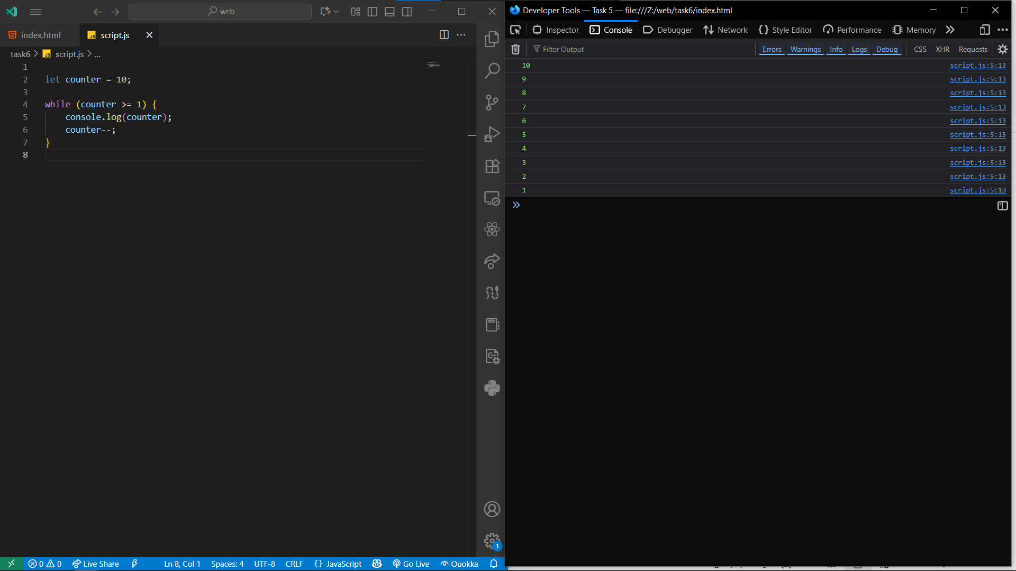

5. Practice using switch to detect fruit names.

Practical 1: Number Check

1. Prompt user for number.

2. Use if-else to check if positive, negative or zero.

3. Display result using alert.

Practical 2: Largest of 3

USE IF-ELSE-IF TO COMPARE THREE NUMBERS. STORE RESULT IN 'MAX'. PRINT USING CONSOLE.LOG.

Practical 3: For Loop 1-10

USE FOR LOOP: I FROM 1 TO 10. PRINT EACH NUMBER USING CONSOLE.LOG.

Practical 4: While Sum 1-100

Use Use while loop to sum numbers from 1 to 100. Initialize Initialize i and sum variables. Print Print total sum.

Practical 5: Loop Array

CREATE ARRAY OF FRUITS. USE FOR...OF TO ITERATE. PRINT EACH FRUIT.

Practical 6: Break & Continue

USE FOR LOOP FROM 1 TO 5. SKIP 3 WITH CONTINUE. STOP AT 5 WITH BREAK.

Student Tasks

Store Store 5 names in array and display with for...of. Print Print multiplication table of 5. Check Check if number is even or odd.

